**BLINKIT PROJECT**

**Data Cleaning:-**

**To** Update the value in Item_Fat_Content. Like (Lf, low fat to Low Fat)  
  
UPDATE blinkit_data

SET Item_Fat_Content = CASE

WHEN Item_Fat_Content IN ('LF', 'low fat') THEN 'Low Fat'

WHEN Item_Fat_Content = 'reg' THEN 'Regular'

ELSE Item_Fat_Content

END;  
  
After run the query check Data have cleaned or not.

SELECT distinct Item_Fat_Content FROM blinkit_data;  
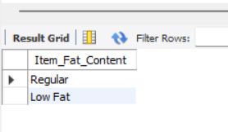

A:KPIs  
  
**1:-Total Sales in Million:**

select cast(sum(Total_Sales)/1000000 as Decimal(10,2)) as Total_Sales_Million

from blinkit_data;

ANS:-Total_Sales_Million:-1.20  
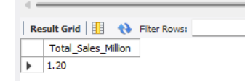

**2:-Ang_Sales:**

select cast(avg(Total_Sales)as Decimal(10,0)) as Avg_Sales from blinkit_data;

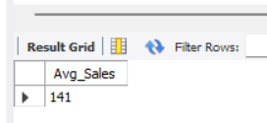

**3:-Number of Items:-**

select count(*) As Number_of_Item from blinkit_data;

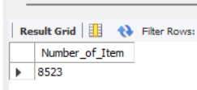

4:- Avg_Rating:-

select cast(avg(Rating) as Decimal(10,2)) as Avg_Rating from blinkit_data;

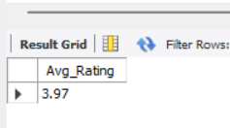

**GRANULAR REQUIRMENTS:-**

**1:-Total_Sales by Fat content:-**

SELECT Item_Fat_Content,concat(cast(sum(Total_Sales)/1000 as Decimal(10,2)), 'K') As Total_Sales_Thousand,

cast(avg(Total_Sales)as Decimal(10,1)) as Avg_Sales,

count(*) As Number_of_Item,

cast(avg(Rating) as Decimal(10,2)) as Avg_Rating

from blinkit_data

group by 1

order by 2 desc

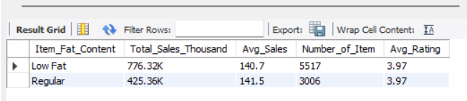

**2:-Total Sales By Item_Type:-**

SELECT Item_Type,cast(sum(Total_Sales) as Decimal(10,2)) As Total_Sales,

cast(avg(Total_Sales)as Decimal(10,1)) as Avg_Sales,

count(*) As Number_of_Item,

cast(avg(Rating) as Decimal(10,2)) as Avg_Rating

from blinkit_data

group by 1

order by 2 desc

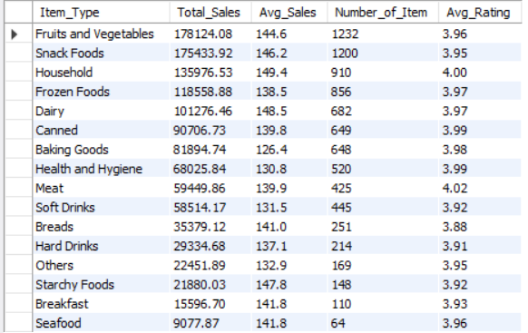

* If we want top 5 we can use Limit function. And down 5 means same limit use but in order by we can use ASC instead if DESC

**3:-Fat Content By Outlet for Total Sales:**

**SELECT**

**Outlet_Location_Type,**

**cast(SUM(CASE WHEN Item_Fat_Content = 'Low Fat' THEN Total_Sales ELSE 0 END) as decimal(10,2))AS Low_Fat,**

**cast(SUM(CASE WHEN Item_Fat_Content = 'Regular' THEN Total_Sales ELSE 0 END)as decimal(10,2)) AS Regular**

**FROM blinkit_data**

**GROUP BY Outlet_Location_Type**

**ORDER BY Outlet_Location_Type;**

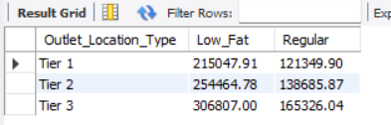

**4:-Total Sales By Outlet Establishment Year:-**

**select Outlet_Establishment_Year,**

**cast(sum(Total_Sales) as Decimal(10,2)) as Total_Sales,**

**cast(avg(Total_Sales)as Decimal(10,0)) as Avg_Sales,**

**count(*) As Number_of_Item,**

**cast(avg(Rating) as Decimal(10,2)) as Avg_Rating**

**from blinkit_data**

**group by 1**

**order by 2 desc**

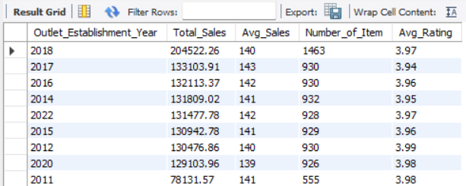

**5:-Percentage of Sales By outlet size:-**

**select Outlet_Size,**

**cast(sum(Total_Sales) as Decimal(10,2)) As Total_Sales,**

**cast((sum(Total_sales) * 100/sum(sum(total_sales)) over ())as decimal(10,2)) As Sales_Percentage**

**From blinkit_data**

**group by 1**

**order by 2 desc**

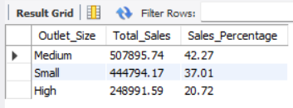

**6:-Sales By Outlaet Location:-**

**select Outlet_Location_Type,**

**cast(sum(Total_Sales) as Decimal(10,2)) as Total_Sales,**

**cast((sum(Total_sales) * 100/sum(sum(total_sales)) over ())as decimal(10,2)) As Sales_Percentage,**

**cast(avg(Total_Sales)as Decimal(10,0)) as Avg_Sales,**

**count(*) As Number_of_Item,**

**cast(avg(Rating) as Decimal(10,2)) as Avg_Rating**

**from blinkit_data**

**group by 1**

**order by 2 desc**

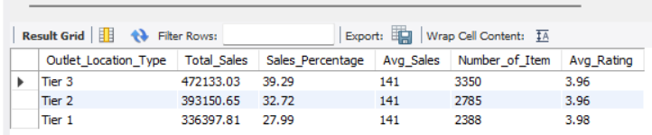

**7:-All Metrics By outlet Type:-**

**select Outlet_Type,**

**cast(sum(Total_Sales) as Decimal(10,2)) as Total_Sales,**

**cast((sum(Total_sales) * 100/sum(sum(total_sales)) over ())as decimal(10,2)) As Sales_Percentage,**

**cast(avg(Total_Sales)as Decimal(10,0)) as Avg_Sales,**

**count(*) As Number_of_Item,**

**cast(avg(Rating) as Decimal(10,2)) as Avg_Rating**

**from blinkit_data**

**group by 1**

**order by 2 desc**

